AVA Northern Golf Day

Thursday 23 July 2026
Wetherby Golf Club, Linton Lane, Linton, Wetherby, LS22 4JF

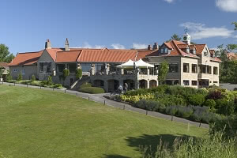
Wetherby has long been the home of this prestigious competition since Jack West first introduced the competition many years ago. This excellent course will once again be the host for the AVA Northern Golf Tournament.

We can’t guarantee the weather, however you can be sure of a warm welcome and an excellent day’s golf will await you at Wetherby Golf Club!
https://www.wetherbygolfclub.co.uk/

THE COMPETITION
Played over 27 holes for the Jack West Trophy, with the Nestlé Trophy presented for the best Stableford score over the 18 holes in the afternoon round.

WHAT IS INCLUDED
- From 9.30 am - Morning Coffee and Bacon rolls
- From 10.26am - 9 holes of golf in the morning (Points then added to afternoon score for Jack West Trophy)
- Light Lunch - sandwiches and chips
- From 1.30pm - Nestle Trophy 18 holes of golf in the afternoon
- 7.30pm - Dinner and Prize giving (smart casual – no golf attire)

COST: £85 per player (+VAT)
To book email paul.fitzjohn@the-ava.com or call 03300 883 267 with details of players, current handicap, and any dietary requirements.


Sponsored by:

Local Accommodation options:
- The Bridge Hotel: Call 01937 543305 for AVA Rate of £89 B&B
- Wood Hall Hotel & Spa
- Days Inn - Wetherby
- Swan & Talbot Inn

Buggies, Trolleys etc should be booked directly with the club: 01937 580089

